A Simulation-based Framework for Growth-Adjusted Life Distribution Forecasting
Placeholder
Placeholder
Key Words: Reliability Growth Analysis, Life Forecasting, Monte Carlo Simulation, Weibull Analysis

SUMMARY & CONCLUSIONS
Reliability growth analysis (RGA) quantifies the improvement in system reliability as design changes are introduced during development. However, translating the observed growth trend into a fleet-level life distribution typically requires several disconnected analyses. This study presents an integrated workflow that connects RGA to life estimation through stochastic simulation, implemented as a reproducible, open-source workflow. The example is structured into two phases. A developmental growth test of sequential prototypes, in which design improvements lead to an improvement trend. This trend is then projected onto a fielded fleet of the matured design: over a fixed forecast window the growth model lowers the number of additional failures expected from the fleet’s own life distribution; a conditional Weibull simulation generates failure times for the surviving units over that window; and the simulated failures are combined with the observed fleet data to fit a growth-adjusted Weibull life distribution. A parallel Weibull fitted to the fleet data alone provides a no-growth baseline for comparisons. Monte Carlo analysis quantifies the variability introduced by growth-parameter uncertainty and the simulation, and sensitivity analyses examine the dependence on the fleet assessment point and the strength of the growth trend. By construction, incorporating the growth trend shifts the characteristic life upward relative to the no-growth baseline. The contribution of the workflow is to formalize and quantify the growth-induced shift in characteristic life by propagating both growth-parameter uncertainty and simulation variability into the forecast; establishing whether this adjustment improves predictive accuracy over no-growth baselines requires validation against a fleet exhibiting true continued growth, which is left to future work. This enables decision-makers to assess whether the observed developmental trend justifies an upward revision of fleet-level reliability estimates and to quantify the forecast’s sensitivity to the assumed growth continuation. The method provides a repeatable means of propagating the observed reliability growth into fleet-level life distribution estimates. Because the projection assumes the developmental growth trend continues to be reflected in field reliability, it is designed to address the potential underestimation of future reliability that may result when growth trends are not propagated into fleet-level forecasts. The forecast should be read as conditional on the developmental growth trend continuing in service. When this assumption is justified, such as when design improvements are expected to persist into fielding, the method provides a quantitative, reproducible means of propagating that growth into fleet-level life estimates, with explicit variability bounds that fragmented analyses do not deliver.
- INTRODUCTION
Reliability growth analysis quantifies how system reliability improves during development, yet translating the observed growth trend into a fleet-level life distribution is rarely formalized. The challenge is compounded by limited life data, particularly for high-reliability, long-life products for which collecting sufficient failure information is costly and time-consuming. As product quality improves, the likelihood of observing failures within a practical test window decreases, creating a data scarcity problem that undermines traditional reliability estimation. The difficulty is compounded by censoring: units are routinely removed from test before failing, or their failure times are known only to fall within an interval, so the effective information content of a campaign is smaller than the sample size suggests [1], [2].
The consequences of analyzing limited, heavily censored data using inappropriate methods are well documented. Maximum likelihood estimation becomes unreliable with small samples, producing biased and highly variable parameter estimates, and the shape parameter of the Weibull distribution is especially sensitive [3]. Most critically, reliability predictions that extrapolate beyond the observed data become unreliable, with serious safety and economic implications [4]. A range of remedies has been proposed, from integrating historical degradation data [5] to generalized inference for remaining useful life [6] and to case-specific Weibull fits for sparse field data [7].
A distinct but under-addressed problem arises when the system is actively being improved during test: the life distribution itself is not fixed. Existing remedies for data scarcity improve the estimation of a static distribution but do not propagate the observed reliability growth trend into fleet-level life predictions. RGA characterizes the system-level failure intensity and is conventionally used to project a future failure count or MTBF. However, this system-level trend is typically analyzed in isolation from unit-level life estimation. As a result, the projected improvement is not reflected in the fleet-level life distribution, and reliability forecasts may systematically underestimate future performance.
This article closes this gap by integrating RGA with conditional Weibull simulation. In contrast to applying a fixed reliability-growth multiplier to a baseline distribution, the growth model here adjusts the failure count expected over a fixed forecast window, a conditional simulation propagates the growth-adjusted failure behavior onto the surviving fleet, and a growth-adjusted Weibull distribution is fitted to the combined data and compared against a no-growth baseline, with the variability of the projection quantified by Monte Carlo. This integrated approach is intended to propagate both growth-parameter uncertainty and simulation variability more transparently than ad hoc multipliers, though empirical comparison of predictive accuracy is left to future work. The forecast is explicitly conditional on the observed growth continuing, where fragmented analyses risk underestimating future reliability, an over-extrapolated growth trend can equally overestimate it, and the framework is intended to make that dependence visible rather than to assert a single-point forecast. The complete workflow is implemented in open-source [8], [9], with Weibull fitting performed by maximum likelihood estimation (MLE) [10].
- Simulation Framework
The framework integrates three sequential stages: growth trend estimation, conditional stochastic simulation, and growth-adjusted life estimation into a unified pipeline that propagates an observed reliability growth trend into a fleet-level Weibull life distribution. The inputs originate from two phases of a program, both involving non-repairable units. A developmental growth test records the cumulative test times of sequential prototypes built under a test-analyze-fix process, and a Crow-AMSAA model (Eqs. 8–11) quantifies the system-level improvement trend. A fielded fleet of the resulting matured design then provides failure and suspension times over a finite campaign of duration $T_{\text{end}}$, to which a two-parameter Weibull distribution (Eq. 7) is fitted to characterize the unit-level failure behavior and to serve as the no-growth baseline. Together, the fitted growth model and fitted Weibull supply the inputs needed for the two subsequent stages.
Stage 1 — Forecast window and growth-adjusted failure count. The forecast is run over a fixed forecast window $w$, a forward increment applied to each surviving unit. Over this window the fitted fleet Weibull (shape $β$, scale $η$) is expected, with no growth, to produce
$F_{0}=\sum_{i=1}^{n_{s}}{\left[1-exp​\left\{-\left[{\left({r_{i}+w}/η\right)}^{β}-{\left({r_{i}}/η\right)}^{β}\right]\right\}\right]}$ (1)
failures among the surviving units, where $r_{i}$ is each unit’s current age.
Reliability growth lowers this count: an improving fleet accumulates failures more slowly. Re-anchoring the Crow-AMSAA scale to the fleet ($λ=N_{\text{current}}/T_{\text{end}}^{ β_{g}}$), the expected additional failures over the cumulative window $Δt=n_{s} w$ are $N_{\text{current}}[(1+ρ)^{β_{g}}-1]$ with $ρ=Δt/T_{\text{end}}$. The same since-inception anchoring enters the no-growth ($β_{g}=1$) case, so its bias cancels when the growth effect is expressed as the ratio of the two,
$c(β_{g})=\frac{(1+ρ)^{β_{g}}-1}{(1+ρ)-1}=\frac{(1+ρ)^{β_{g}}-1}{ρ},$ (2)
which satisfies $c(1)=1$ and decreases as the growth strengthens ($β_{g}​↓$). The growth-adjusted target failure count over the window is then
$n=F_{0} c(β_{g}).$ (3)
Because $c(1)=1$, with no growth the target reduces to the forward-correct benchmark $F_{0}$ and the calibrated scale (Stage 2) returns the fitted fleet value; the growth effect enters only through $c(β_{g})<1$, which forces a larger scale to reproduce the reduced count. The projection thus assumes only that the relative growth reduction estimated in development carries over to the fleet. Because the power law is scale-free, only the fractional increment $ρ$ and the dimensionless $β_{g}$ enter $c$, so no developmental time unit is imported into the fleet forecast.
Stage 2: Conditional Weibull simulation. Each surviving unit enters the simulation window with a known current runtime $r_{i}$. The probability of failing within the window $[r_{i},r_{i}+w]$, conditional on having survived to $r_{i}$, is:
$p_{i}=1-exp​\left\{-\left[{\left({r_{i}+w}/η\right)}^{β}-{\left({r_{i}}/η\right)}^{β}\right]\right\},$ (4)
The scale parameter $η$ is calibrated so that the expected number of conditional failures over the window matches the target count $n$:
$\sum_{i=1}^{n_{s}}{p_{i}}(η)=n,$ (5)
which is solved numerically for $η$. The calibrated $η$ reflects reliability growth: because the growth-adjusted failure rate is lower than the rate observed during the test, a larger characteristic life is required to produce the same expected failure count. This upward shift in $η$ is therefore a mechanistic consequence of spreading the target failures over the longer, growth-extended horizon $w$ rather than an independently discovered effect; the framework’s role is to quantify its magnitude and variability, not to establish its existence. Units are then sampled with probability proportional to $p_{i}$, and a failure time for each selected unit is drawn by inverse-transform sampling of the truncated conditional Weibull:
$t_{i}=η{\left[{\left({r_{i}}/η\right)}^{β}-ln​(1-U_{i}(1-e^{-Δh_{i}}))\right]}^{1/β},$ (6)
where $U_{i}∼\text{Uniform}(0,1)$ and $Δh_{i}=((r_{i}+w)/η)^{β}-(r_{i}/η)^{β}$. The non-selected units are right-censored at $r_{i}+w$. The procedure is summarized in Algorithm 1:
Algorithm 1 — Conditional Weibull failure simulation 1. Calibrate the scale $η$ by solving Eq. (5) for the target count $n$. 2. Compute the per-unit window failure probability $p_{i}$, Eq. (4). 3. Sample $n$ units with probability proportional to $p_{i}$. 4. Draw a failure time for each selected unit by inverse transform, Eq. (6). 5. Label the remaining units as suspensions at $r_{i}+w$.
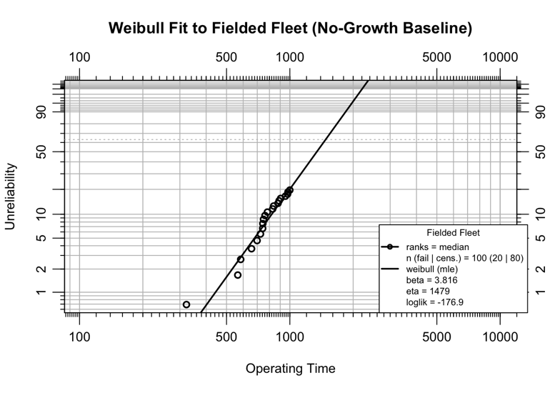
Stage 3: Growth-adjusted Weibull fit and Monte Carlo variability assessment. The simulated failure and suspension times are combined with the observed fleet failures to form an augmented dataset. A Weibull is fitted to obtain the growth-adjusted life distribution, and a parallel Weibull fitted to the fleet data alone serves as the no-growth baseline. The growth effect manifests primarily as an increase in the estimated characteristic life $η$: the simulated failures occur later than they would under the no-growth failure rate, shifting the distribution rightward. The headline comparison fits a two-parameter Weibull by maximum likelihood to both the baseline and the growth-augmented data, so the two differ only in their data, and reports the B10 life as the summary indicator. To characterize the variability in the forecast, Stages 1 and 2 are repeated $M$ times: each iteration resamples the estimated growth parameter $β_{g}$ from its sampling distribution and recomputes the growth-adjusted count $n$ (Eqs. 2–3), redraws the conditional failures over the window, and refits the Weibull, so that both growth-parameter estimation uncertainty and simulation randomness are reflected in the resulting empirical distributions of $\hat{β}$ and $\hat{η}$, which are summarized by medians and 95% percentile intervals.
Figure 1: Weibull fit to the fielded fleet (no-growth baseline)
- Case Study
The case study proceeds in two steps. First, a reliability growth analysis fits the Crow-AMSAA model to a developmental growth test in which prototypes are built and tested to failure in sequence. Second, a Weibull life analysis characterizes a fielded fleet of 100 units of the matured design, each observed over a 1000 time-unit campaign. The growth trend estimated in the first step is then projected onto the fleet to forecast its life distribution. Both phases involve non-repairable units.
The failure mechanism is wear-out; therefore, the hazard rate increases with age. To provide a reproducible example, the failure and right-censored suspension times are simulated from the matured Weibull population (shape 4, scale 1456, random seed 8): each unit is assigned a lifetime, units that fail before the end of the campaign are recorded as exact failures, and the remainder are right-censored at the end of the campaign.
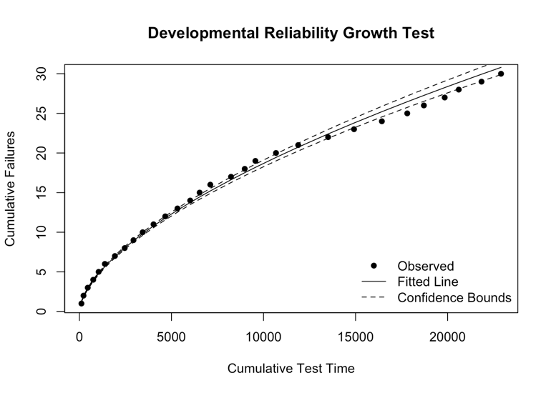
In this illustrative example, the no-growth baseline fitted below coincides with the ground-truth life distribution, and the growth-adjusted forecast developed in the later sections is the optimistic bound that would apply only if the developmental improvement trend continued into service. The example is intended to demonstrate the mechanics and magnitude of that growth adjustment, not its predictive accuracy against a fleet that truly keeps improving (see the Limitations section)
This draw yields 20 exact failures, leaving 80 surviving units at risk during the forecast period. A two-parameter Weibull distribution is fitted to the failure and suspension data using maximum likelihood estimation, providing the no-growth baseline life distribution. The Weibull cumulative distribution function is
Figure 2: Developmental Reliability Growth Test
$F(t)=1-exp​\left[-{\left(t/η\right)}^{β}\right], t>0$ (7)
where $β$ is the shape parameter and $η$ is the scale (characteristic life).
Figure 1 shows the Weibull fit to the fielded fleet with no growth. The estimated shape parameter is $β$ = 3.816 and the scale parameter is $η$ = 1479.4. A shape parameter greater than one confirms the wear-out failure mode. This Weibull $β$ describes the unit-level hazard in individual age and is distinct from the Crow-AMSAA growth parameter $β_{g}$ introduced next, which describes the system-level failure-intensity trend.
  - Reliability Growth Analysis
A Crow-AMSAA non-homogeneous Poisson process NHPP model [11] is fitted to the developmental record. The expected cumulative number of failures by cumulative operating time $t$ is:
$N(t)=λ t^{β_{g}}$ (8)
with corresponding failure intensity:
$ρ(t)=\frac{dN(t)}{dt}=λ β_{g} t^{β_{g}-1}$ (9)
By default, the parameters are estimated by ordinary least squares on the linearized form of (8).
$lnN(t)=lnλ+β_{g}lnt$ (10)
Alternatively, the parameters can be estimated using the maximum likelihood method. The reliability growth rate is expressed as
$g=1-β_{g}$ (11)
A value $β_{g}<1$ (equivalently $g>0$) indicates reliability improvement.
Figure 2 shows the reliability growth model for the developmental phase. The fitted growth parameter is $β_{g}$ = 0.603 ($R^{2}$ = 0.996), indicating a decreasing failure intensity as the design matured, and the reliability growth rate (11) is $g=1-β_{g}$ = 0.397.
  - Reliability Growth Forecast
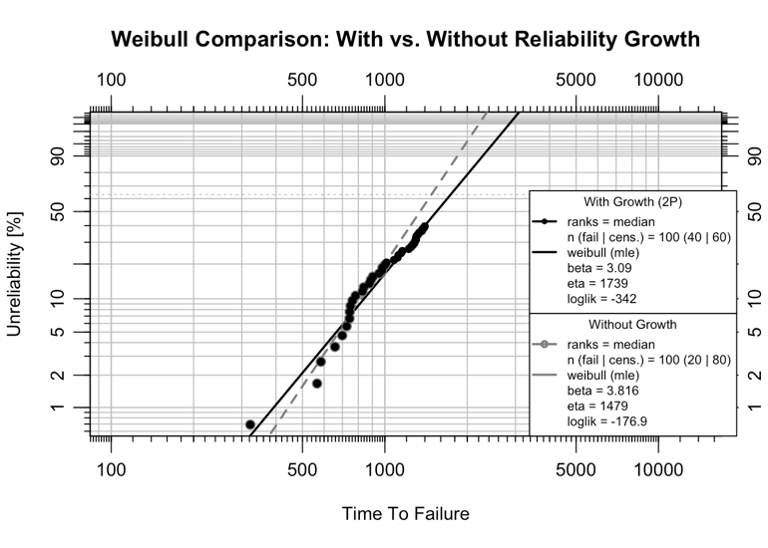
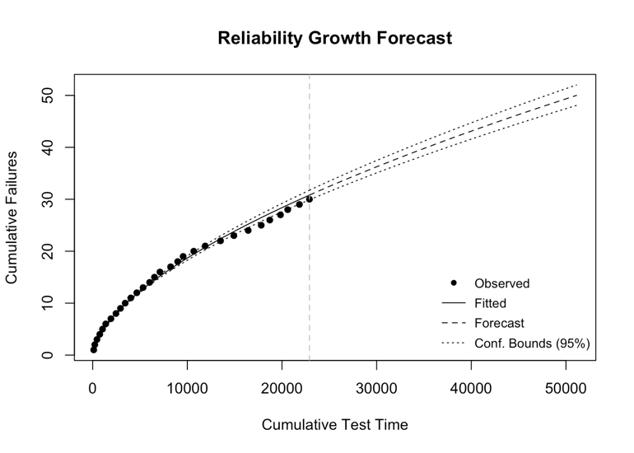
The growth trend is projected onto the fielded fleet, following the Stage 1 procedure of the Simulation Framework section. The forecast is run over a fixed forecast window. Over that window the fitted fleet Weibull sets the no-growth failure count, and the growth rate $β_{g}$ imported from the developmental test lowers it through the Crow-AMSAA count-ratio. Re-anchoring the Crow-AMSAA scale to the fleet ($λ=N_{\text{current}}/T_{\text{end}}^{ β_{g}}$, with $T_{\text{end}}$ the fleet’s cumulative operating time and $N_{\text{current}}$ the failures observed so far) makes that ratio pass through the fleet’s observed state. Therefore, the forecast is conditional on the developmental growth trend continuing to be reflected in the field reliability.
Figure 3: Weibull comparison with & without reliability growth
Figure 4 shows the reliability growth forecast beyond the developmental phase. Over the forecast window of $w$ = 400 operating time units, the fitted fleet Weibull expects $F_{0}$ = 35.5 failures with no growth (Eq. 1). The Crow-AMSAA growth count-ratio (Eq. 2) is $c$ = 0.57, lowering the growth-adjusted target to $n$ = 20 additional failures (Eq. 3), for a total of 40 cumulative failures.
  - Simulating Failures
Conditional Weibull failure times for the 80 surviving units are generated using Algorithm 1. Each unit has already accumulated 1000 operating time units; failure times are therefore drawn from the Weibull distribution conditional on the current age over the forecast window $w$.
The calibrated scale parameter is $η$ = 1573.3, compared with the no-growth fleet estimate of $η$ = 1479.4. The increase is the mechanical consequence of the assumed growth: growth lowers the expected failure count over the fixed window, so a larger characteristic life is required to reproduce the reduced count. Of the 80 surviving units, 13 receive simulated failure times and 67 are right-censored at the end of the window. The simulated failures are combined with the 20 observed fleet failures.
  - Weibull Comparison
Two Weibull models are fitted to contrast the effect of reliability growth. The without-growth model is fitted to the fielded fleet data alone (20 failures, 80 suspensions at $t=1000$), representing the life distribution implied by the fleet without projecting the growth trend forward. The with-growth model is fitted to the combined dataset (20 fleet failures, 20 simulated failures, and 60 suspensions), representing the life distribution when growth-adjusted failure times are included. Table 1 shows the parameters and B10 life for the two Weibull models, and Figure 4 shows the Weibull plot comparison.
Figure 4: Developmental growth model forecast
Table 1: Weibull parameters and B10 life: with vs. without reliability growth
Scenario | β | η | B10
Without Growth (2P) | 3.816 | 1479.4 | 820.3
With Growth (2P) | 3.090 | 1739.0 | 839.5
  - Monte Carlo Analysis
A single simulation produces one realization of the 13 forecast failure times; different random draws yield different combined datasets and therefore different Weibull estimates. To characterize this variability, the simulation is repeated 500 times following the Monte Carlo procedure of the Simulation Framework section. Two sources of variability are propagated. Each iteration draws $β_{g}$ from its sampling distribution and recomputes the growth-adjusted failure count over the fixed window from Eqs. (2)–(3); it then redraws the forecast failures, combines them with the fleet failures, and refits a Weibull distribution with both parameters freely estimated. In this example the developmental trend is estimated precisely, the cumulative-data fit pins $β_{g}$ down with a small standard error, so the resulting spread is dominated by the conditional simulation, with growth-parameter uncertainty included for completeness but contributing little. The Monte Carlo and sensitivity loops fit two-parameter Weibulls by maximum likelihood, matching the headline comparison; therefore, the B10 life is directly comparable throughout.
The fitted $\hat{β}$, $\hat{η}$, and B10 life across all valid iterations are summarized in Table 2; the median and 95% percentile interval describe the spread introduced by the propagated growth-parameter uncertainty and the stochastic simulation, with the no-growth baseline shown for reference.
Table 2: Monte Carlo summary of Weibull parameters and B10 life (500 valid iterations)
Param | No Growth | Median | 2.5% | 97.5%
β | 3.816 | 3.013 | 2.880 | 3.140
η | 1479.424 | 1743.035 | 1716.308 | 1753.066
B10 | 820.290 | 825.069 | 801.951 | 846.482
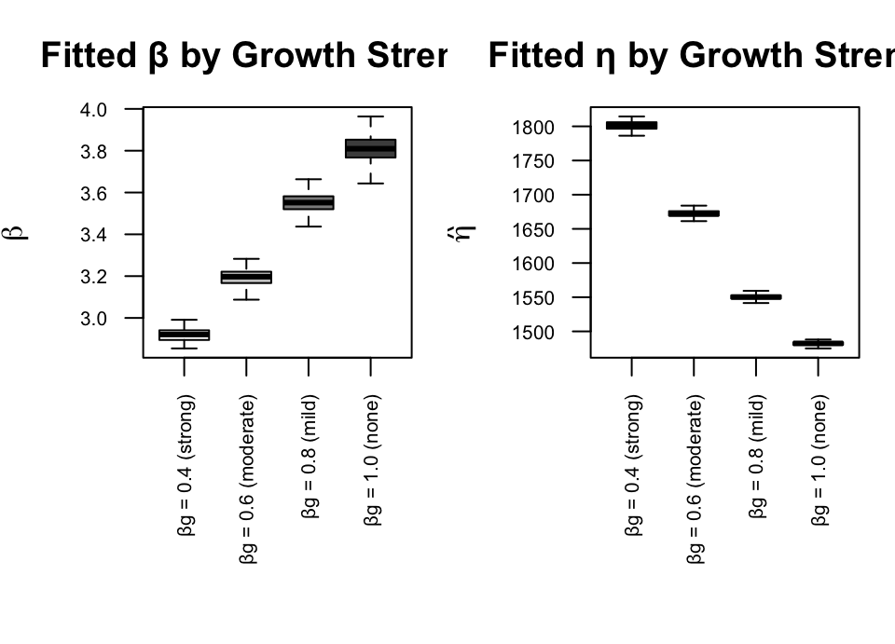
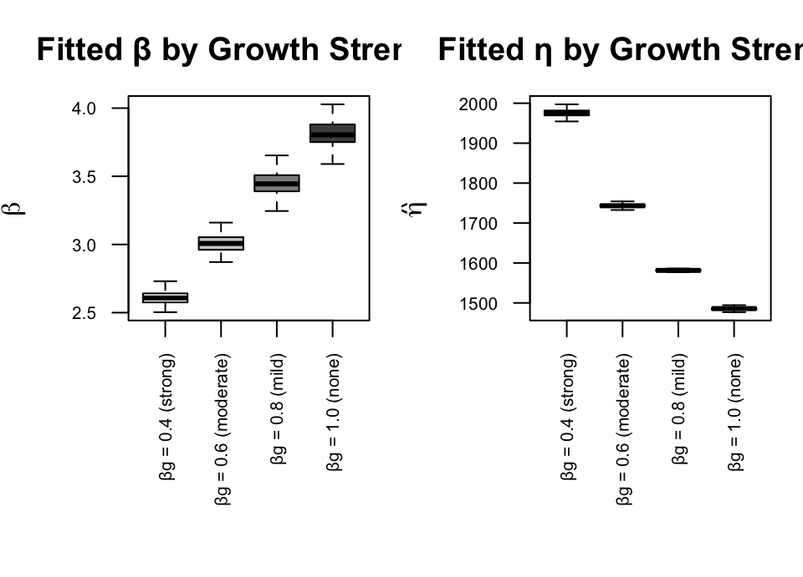The Monte Carlo distributions quantify how much the growth-adjusted Weibull estimates vary across repeated simulations, here almost entirely from the stochastic simulation rather than from growth-parameter estimation uncertainty. These bands represent the variability of the forecast conditional on the fitted growth model and the assumed growth continuation, not inferential confidence intervals. They quantify the repeatability of the method and the sensitivity of the forecast to simulation randomness, but they do not assess the accuracy of the growth assumption itself. They should be read as forecast variability bands conditional on the fitted model and the assumed growth scenario, not as inferential confidence intervals or a hypothesis test; in particular, model-form uncertainty (the choice of the Crow-AMSAA power law) is not represented. The separation between the no-growth baseline and the Monte Carlo distribution of $\hat{η}$ reflects the genuine growth reduction in the failure count ($c(β_{g})<1$); with no growth the target reduces to $F_{0}$ and the distribution centers on the baseline.
Figure 5: Weibull parameters by growth parameter
  - Sensitivity Analysis
The Monte Carlo analysis held the fleet assessment and the input shape parameter fixed while varying the simulated draws. This section examines how two key inputs affect the growth-adjusted Weibull: the fleet assessment point and the strength of the growth trend. Each scenario runs 200 iterations.
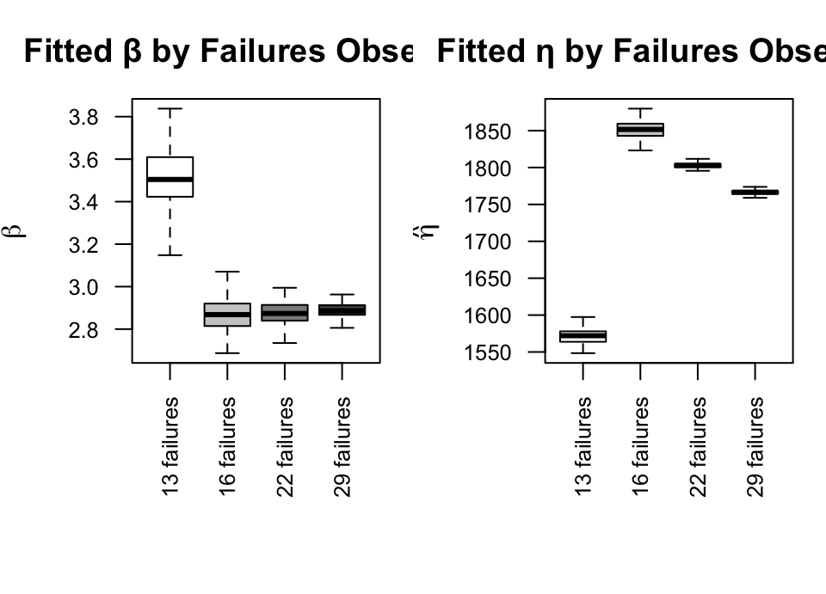
Effect of fleet assessment point - The point at which the fleet is assessed sets how many failures have been observed and how the baseline fleet Weibull is fitted, which feed the no-growth count $F_{0}$ over the window. The same fleet is assessed at four service points, yielding progressively more observed failures.
Figure 6: Weibull parameters by failures observed
Figure 5 shows the Weibull parameters by increasing failures observed. Across the four assessment points the growth count-ratio is essentially constant ($c≈0.8$), so the growth adjustment itself is robust to when the fleet is assessed; the visible variation is inherited from the baseline Weibull fit, which is depressed by the heavy censoring of an early assessment (13 observed failures) and stabilizes once enough failures have accrued. The practical implication is that a dependable growth forecast depends less on the assessment timing than on having enough observed failures to pin down the fleet’s baseline life distribution.
Effect of growth parameter - The growth parameter $β_{g}$ controls the growth count-ratio $c(β_{g})$: stronger growth (smaller $β_{g}$) lowers the expected failure count over the fixed window, producing fewer simulated failures and a larger fitted $η$. Four growth scenarios are examined while holding all other inputs fixed; each scales the same no-growth count $F_{0}$ by its ratio $c(β_{g})$, so the scenarios differ only in the growth strength.
Figure 6 shows the Weibull parameters by increasing growth parameter. Stronger reliability growth (smaller $β_{g}$) lowers the expected failure count over the fixed window through the count-ratio $c(β_{g})$, producing fewer simulated failures and a larger fitted $η$. At $β_{g}=1$ (no growth) the ratio $c(1)=1$ leaves the target at the forward-correct no-growth count $F_{0}$, and the growth-adjusted distribution recovers the no-growth baseline — its median $η$ returns to the fitted fleet value up to Monte Carlo noise. The growth-adjusted $η$ therefore rises monotonically from the baseline as the growth strengthens, so the reported shift is attributable entirely to the estimated growth trend. Taking the no-growth count from the fleet’s forward hazard (rather than from the Crow-AMSAA since-inception average rate) is what removes the offset that a purely cumulative-rate target would leave at $β_{g}=1$.
- Limitations
The forecast projects the developmental improvement trend into service, and it inherits the sampling behavior of the fleet’s baseline Weibull fit. The Sensitivity Analysis (effect of fleet assessment point) shows that when few failures have been observed, the heavily censored baseline fit is unstable, which propagates into the growth-adjusted forecast; a dependable forecast therefore requires enough observed failures to pin down the fleet’s baseline life distribution. Results are conditional on the growth trend continuing to be reflected in field reliability. If the design is frozen at fielding and no further improvement occurs, the projection overstates the gain and the no-growth baseline applies. Therefore, the forecast is best read as the optimistic bound under continued improvement.
The present study demonstrates the mechanics and magnitude of the growth adjustment and provides a reproducible framework for propagating developmental growth trends into fleet-level forecasts. Establishing whether the method improves on the no-growth baseline in predictive accuracy requires a validation study in which the fleet’s true future life genuinely continues along the estimated growth trend, so that the forecast can be compared against a held-out ground truth. Such validation is left to future work.
Finally, the Monte Carlo analysis propagates estimation uncertainty in the growth parameter $β_{g}$, though because the cumulative-data fit estimates are precise, that contribution is small and the spread is dominated by the conditional simulation. Two uncertainty sources remain unrepresented: model-form uncertainty in the choice of the Crow-AMSAA power law, and the input Weibull shape $β$, which is held fixed at its fielded-fleet estimate across iterations rather than resampled. Holding $β$ fixed is also a structural modeling choice, distinct from that sampling question: reliability growth is treated as a scale effect that lengthens the characteristic life $η$ while leaving the unit-level failure-mode shape $β$ unchanged. A design change that reshapes the failure mode — rather than delaying it — would move $β$ in a mode-specific direction that the growth parameter $β_{g}$ does not determine and is therefore outside the model’s scope. Alternative growth models such as the piecewise NHPP with change-point detection [12], available through segmented regression [13], may yield different growth counts and life distributions. The simulation assumes a homogeneous fleet drawn from a single conditional Weibull distribution and that failed units are not replaced; distinct subpopulations would require separate analyses. .
REFERENCES
- C. W. Zhang, T. Zhang, D. Xu, and M. Xie, “Analyzing highly censored reliability data without exact failure times: An efficient tool for practitioners,” Quality Engineering, 2013, doi: 10.1080/08982112.2013.783598.
- O. A. Alqasem and A. Elshahhat, “Reliability analysis of the newly power half-normal model via improving adaptive progressive type II censoring and its applications,” Quality and Reliability Engineering International, 2025, doi: 10.1002/qre.3817.
- E. Makalic and D. F. Schmidt, “Minimum message length inference of the Weibull distribution with complete and censored data,” in AI 2023: Advances in artificial intelligence, in Lecture notes in computer science, vol. 14471. Springer, 2023, pp. 291–303. doi: 10.1007/978-981-99-8388-9_24.
- Y. Lou, H. Zheng, and J. Yang, “Optimal design of reliability acceptance sampling plan based on constant-stress accelerated life testing considering the uncertainty of accelerated factor,” Quality and Reliability Engineering International, vol. 39, pp. 1318–1333, 2023, doi: 10.1002/qre.3295.
- W. Kang et al., “Reliability analysis based on the wiener process integrated with historical degradation data,” Quality and Reliability Engineering International, 2023, doi: 10.1002/qre.3300.
- Z. Yan, L. Sun, and Y. Liang, “Remaining useful life analysis for two-stage nonlinear inverse gaussian process with random effects,” Quality and Reliability Engineering International, 2025, doi: 10.1002/qre.3729.
- T. M. Grile and R. A. Bettinger, “Reliability analysis of deep space satellites launched 1991–2020: Bulk population and deployable satellite performance analysis,” Quality and Reliability Engineering International, 2024, doi: 10.1002/qre.3600.
- P. Govan, “ReliaGrowR: Modeling and plotting functions for reliability growth analysis,” in 2026 annual reliability and maintainability symposium (RAMS), Miramar Beach, USA, 2026, pp. 1–6. doi: 10.1109/RAMS50514.2026.11424445.
- P. Govan, ReliaGrowR: Reliability growth analysis. 2024. doi: 10.32614/CRAN.package.ReliaGrowR.
- D. Silkworth and J. Symynck, WeibullR: Weibull analysis for reliability engineering. 2025. Available: https://CRAN.R-project.org/package=WeibullR
- L. H. Crow, “Reliability analysis for complex, repairable systems,” U.S. Army Materiel Systems Analysis Activity (AMSAA), Aberdeen Proving Ground, MD, Technical Report No. 138, 1975.
- H. Guo, A. Mettas, G. Sarakakis, and P. Niu, “Piecewise NHPP models with maximum likelihood estimation for repairable systems,” in 2010 annual reliability and maintainability symposium (RAMS), 2010. doi: 10.1109/RAMS.2010.5448029.
- V. M. R. Muggeo, “Segmented: An R package to fit regression models with broken-line relationships,” R News, vol. 8, no. 1, pp. 20–25, 2008, Available: https://cran.r-project.org/doc/Rnews/
BIOGRAPHIES
Placeholder
Placeholder

